
QUALITY ALERT

Customer: H-PAC Date: April 23, 2019
Die: 15238 / 15191 / 15192 Colour: ALL
Type of Complaint: HPAC REJECTED

Q.A # Q.I.R # CUSTOMER NCR #

Description: HPAC Rejected due panel being too shiny / shine lines showing
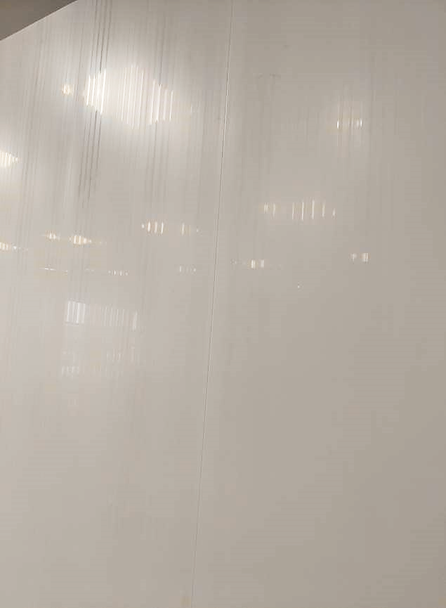
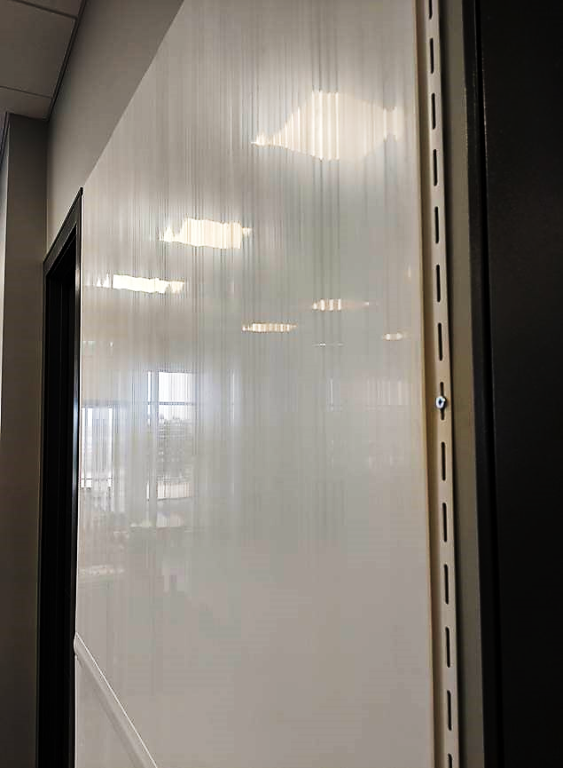
REJECTED SAMPLES

DAY SHIFT |  | AFTERNOON SHIFT |  | NIGHT SHIFT
NAME | SIGNATURE | NAME | SIGNATURE | NAME | SIGNATURE

